WORKBOOK
TASK 5
Fake Trip

Name:______________________________________________

Class:_______________________________________________

Teacher:_____________________________________________

Spoken English:
Mining:
English | Dutch |  |  |  | English |  | Dutch
followers |  |  |  |  | bridge
architecture |  |  |  |  | future
outlet |  |  |  |  | holiday
degree |  |  |  |  | dream
flight |  |  |  |  | The UK
luggage |  |  |  |  | beach
jet-lag |  |  |  |  | sun
airport |  |  |  |  | shadow
suitcase |  |  |  |  | fake
plane |  |  |  |  | different
sightseeing |  |  |  |  | confused
liar |  |  |  |  | scary
story |  |  |  |  | rough
roommate |  |  |  |  | stressful
pub |  |  |  |  | tired
tea room |  |  |  |  | fancy
trip |  |  |  |  | crazy
art |  |  |  |  | cozy
phone booth |  |  |  |  | soft
city trip |  |  |  |  | long
memories |  |  |  |  | lovely
subway |  |  |  |  | freezing
metro |  |  |  |  | realistic
view |  |  |  |  | easily
weather |  |  |  |  | massive
English | Dutch |  |  |  | English + list Dutch
sad |  |  |  |  | terminal
real |  |  |  |  | high tea
nervous |  |  |  |  | precautions
definitely |  |  |  |  | expectation
without |  |  |  |  | opportunity
tomorrow |  |  |  |  | swing
worth |  |  |  |  | difficulties
(to) look |  |  |  |  | angle
(to) trick |  |  |  |  | anxiety
(to) pull off |  |  |  |  | unique
(to) think |  |  |  |  | genuine
(to) believe |  |  |  |  | original
(to) feel |  |  |  |  | tricky
(to) find out |  |  |  |  | reality
(to) drive |  |  |  |  | honestly
(to) pack |  |  |  |  | excited
(to) leave |  |  |  |  | legit
(to) travel |  |  |  |  | technically
(to) rain |  |  |  |  | current
(to) change |  |  |  |  | (to) brag
(to) arrive |  |  |  |  | (to) fabricate
(to) wait |  |  |  |  | (to) recognize
(to) sleep |  |  |  |  | (to) notice
(to) steal |  |  |  |  | (to) mention
(to) try |  |  |  |  | (to) fail

STEP 1: Answer the questions about the video
1. What are Lindsay and Jazzmyne going to try?
2. What makes it difficult?
3. Where is their first post?
4. How do people react to their posts?
5. Why did they almost get busted?
6. How did they do overall?

STEP 2: Answer the questions about Roxx’s video
7. What is her first post?
8. Why is she wearing her bikini in the cold garden?
9. How do people find out her trip is fake?
STEP 3: Answer the questions about the New York Instagram Story
10. How did they get around the city?
11. What kind of accommodation are they staying in?
12. Which sightseeing did they do in New York?
STEP 6
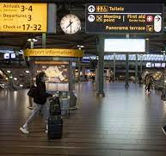 | 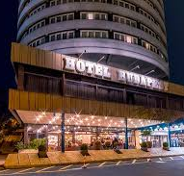 | 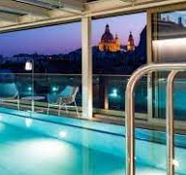

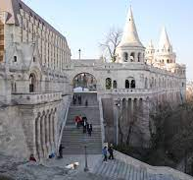 | 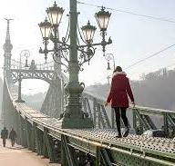 | 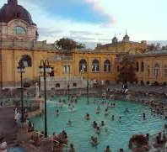

STEP 7/13
Teacher feedback – DON’T WRITE HERE!!!

STEP 14
Grammar Notes

STEP 15
Sentence
STEP 18 / STEP 19
STEP 22
Checklist
- I have translated all the words in my workbook.
- I have answered all the questions on page 4 of my workbook.
- I have written two sentences and two hashtags for each photo for Produce I.
- I have asked and received feedback from my teacher on the Fake trip to Budapest.
- I have written a sentence with the grammar.
- I have done all the vocab checks I could do so far.
- I have used 10 words from the word list in my produce phase I and II.
- I have found or made six pictures for my own fake trip.
- I have written two sentences for each photo for my own fake trip.
- I have come up with two hashtags for each photo for my own fake trip.

If you checked all the boxes, go to step 23 on the website.

STEP 23
Teacher feedback – DON’T WRITE HERE!!!

