WORKBOOK
TASK 1
Social Media Profile

Name:______________________________________________

Class:_______________________________________________

Teacher:_____________________________________________

Spoken English:
Mining:
English | Dutch |  |  |  | English |  | Dutch
address |  |  |  |  | PE
photograph |  |  |  |  | geography
age |  |  |  |  | history
city |  |  |  |  | mathematics
birthday |  |  |  |  | arts
email address |  |  |  |  | sport
job |  |  |  |  | swimming
nationality |  |  |  |  | football
hobby |  |  |  |  | tennis
name |  |  |  |  | the Netherlands
surname |  |  |  |  | Turkey
family |  |  |  |  | Morocco
father |  |  |  |  | Spain
mother |  |  |  |  | cinema
sister |  |  |  |  | singer
brother |  |  |  |  | food
parent |  |  |  |  | Dutch
friend |  |  |  |  | English
pet |  |  |  |  | favorite
horse |  |  |  |  | British
rabbit |  |  |  |  | French
cat |  |  |  |  | German
dog |  |  |  |  | Moroccan
school subject |  |  |  |  | Spanish
music |  |  |  |  | special
English | Dutch |  |  |  | English + list Dutch
tall |  |  |  |  | husband
Turkish |  |  |  |  | wife
about |  |  |  |  | female
eight |  |  |  |  | male
eighteen |  |  |  |  | siblings
eleven |  |  |  |  | ethnic
fifteen |  |  |  |  | be born (v)
five |  |  |  |  | first
fourteen |  |  |  |  | century
interested |  |  |  |  | eighth
in common |  |  |  |  | English-speaking
nine |  |  |  |  | average
nineteen |  |  |  |  | seventh
one |  |  |  |  | sixth
seven |  |  |  |  | complete
seventeen |  |  |  |  | expensive
six |  |  |  |  | same
sixteen |  |  |  |  | member
ten |  |  |  |  | fifth
thirteen |  |  |  |  | second
three |  |  |  |  | fourth
twelve |  |  |  |  | nineth
twenty |  |  |  |  | tenth
two |  |  |  |  | type
four |  |  |  |  | third

STEP 1: Answer questions example 1
1. What are miss Walraven’s hobbies?
2. How many siblings does miss Walraven have?

STEP 2: Answer questions example 2
3. Where does miss Libbers live?
4. What does miss Libbers like to do in her free time?
5. Name two things miss Libbers and miss Walraven have in common.
6. Name two differences between miss Libbers and miss Walraven.
STEP 3: Answer questions example 3
7. What is Ariana’s job?
8. Name two things miss Libbers and Ariana Grande have in common.
9. Name two differences between miss Walraven and Ariana Grande.
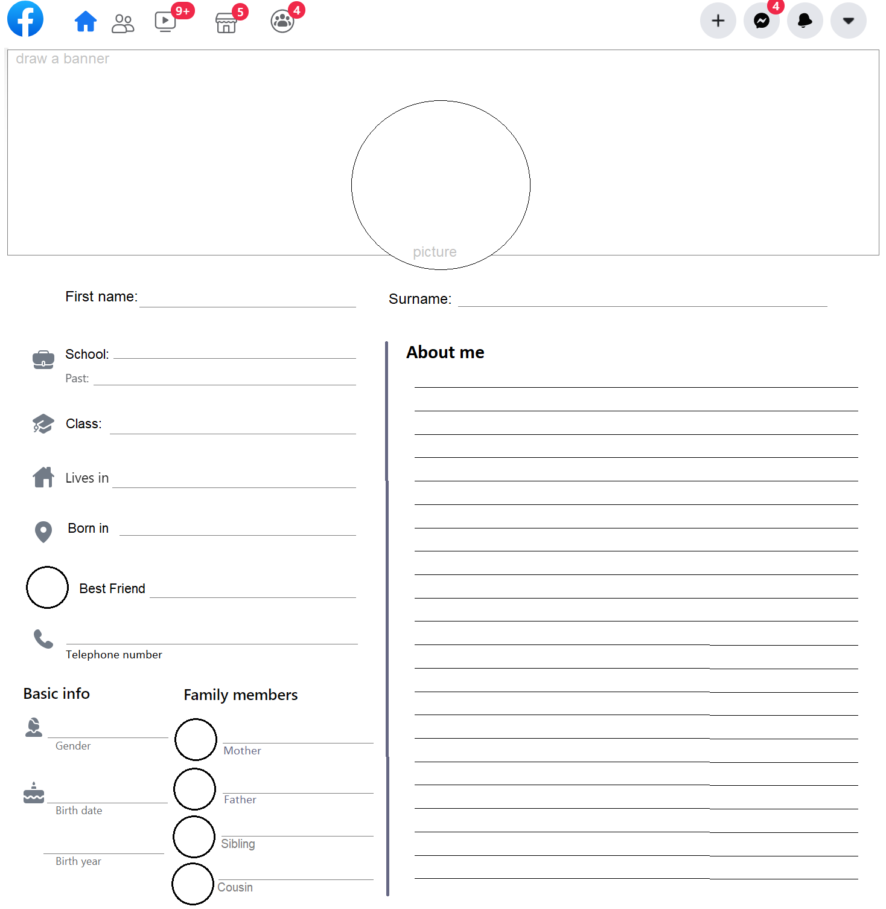
STEP 6
STEP 10
Teacher feedback – DON’T WRITE HERE!!!

STEP 14
Grammar Notes

STEP 15
Sentence
STEP 19
STEP 22
Checklist
- I have translated all the words in my workbook.
- I have filled in the social media profile about myself.
- I have filled in the social media profile about a classmate.
- I have read the examples 1, 2 and 3.
- I have answered the questions in my workbook.
- I have asked and received feedback from my teacher on my social media profile.
- I have written a sentence with the grammar.
- I have done all the vocab checks I could do so far.
- I have used 10 words from the word list in my produce phase I and II.

If you checked all the boxes, go to step 23 on the website.

STEP 23
Teacher feedback – DON’T WRITE HERE!!!

