WORKBOOK
TASK 4
Postcard

Name:______________________________________________

Class:_______________________________________________

Teacher:_____________________________________________

Spoken English:
Mining:
English | Dutch |  |  |  | English |  | Dutch
(to) see |  |  |  |  | did
(to) go |  |  |  |  | bought
(to) stay |  |  |  |  | slept
(to) walk |  |  |  |  | swam
(to) cycle |  |  |  |  | flew
(to) do |  |  |  |  | drove
(to) buy |  |  |  |  | wrote
(to) wish |  |  |  |  | ate
(to) sleep |  |  |  |  | met
(to) swim |  |  |  |  | had
(to) watch |  |  |  |  | saw
(to) fly |  |  |  |  | came
(to) drive |  |  |  |  | gave
(to) like |  |  |  |  | left
(to) write |  |  |  |  | thought
(to) eat |  |  |  |  | yesterday
(to) meet |  |  |  |  | today
(to) say |  |  |  |  | tomorrow
(to) come |  |  |  |  | morning
(to) give |  |  |  |  | soon
(to) leave |  |  |  |  | beautiful
(to) think |  |  |  |  | amazing
(to) enjoy |  |  |  |  | wonderful
saw |  |  |  |  | with
went |  |  |  |  | through
English | Dutch |  |  |  | English + list Dutch
holiday |  |  |  |  | (to) read
present |  |  |  |  | (to) sit
time |  |  |  |  | (to) speak
whale |  |  |  |  | (to) spend
bridge |  |  |  |  | sat
view |  |  |  |  | spent
trip |  |  |  |  | spoke
sightseeing |  |  |  |  | sunscreen
turtle |  |  |  |  | swimming trunks
afraid |  |  |  |  | swimsuit
bye |  |  |  |  | lake
dear |  |  |  |  | waterfall
plane |  |  |  |  | mountain
boat |  |  |  |  | island
ship |  |  |  |  | cave
America |  |  |  |  | countryside
United Kingdom |  |  |  |  | post office
England |  |  |  |  | church
Australia |  |  |  |  | luggage
bike |  |  |  |  | guidebook
car |  |  |  |  | gloves
ticket |  |  |  |  | helicopter
souvenir |  |  |  |  | motorbike
Scotland |  |  |  |  | coach
train |  |  |  |  | adventurous

STEP 1: Answer questions postcard 1
1. Who wrote the postcard?
2. Where is the writer of the postcard?
3. Does the writer like his vacation?

STEP 2: Answer questions postcard 2
4. How does Ayse start her postcard?
5. How does Ayse end her postcard?
6. How does Ayse say where she is staying?
7. About which things does Ayse write?
STEP 3: Answer questions postcard 3
8. How does John Say that he like his holiday?
9. What did John do yesterday?
10. What is John going to do tomorrow?

STEP 6
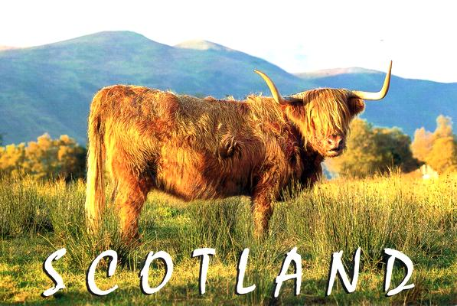
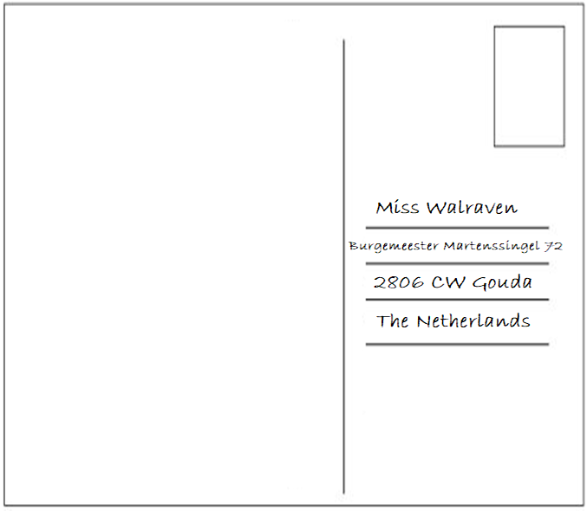
STEP 7/13
Teacher feedback – DON’T WRITE HERE!!!

STEP 14
Grammar Notes

STEP 15
Sentence
STEP 18 / STEP 19

STEP 22
Checklist
- I have translated all the words in my workbook.
- I have answered the questions for all three postcards.
- I have written postcard A in my workbook.
- I have asked and received feedback from my teacher on postcard A.
- I have written a sentence with the grammar.
- Postcard A and B are between 40 and 70 words each (address doesn’t count).
- I wrote down the address on postcard B.
- I have written about a-f in postcard B.
- I have done all the vocab checks I could do so far.
- I have used 10 words from the word list in my produce phase I and II.

If you checked all the boxes, go to step 23 on the website.

STEP 23
Teacher feedback – DON’T WRITE HERE!!!

