WORKBOOK
Task 1
Advertisement

Name:______________________________________________

Class:_______________________________________________

Student number:______________________________________

Spoken English:

Mining:

English | Dutch |  | English | Dutch
advertisement |  |  | basket
(to) offer |  |  | (to) carry on
discount |  |  | stranger
(to) save |  |  | stepfather
promo |  |  | (to) wish
shipping |  |  | grubby
member |  |  | (to) budget
(to) verify |  |  | (to) pay
item |  |  | bills
(to) receive |  |  | independently
(to) redeem |  |  | homeless
original |  |  | price
exclusive |  |  | size
trainers |  |  | advice
material |  |  | (to) sponsor
leather |  |  | details
textile |  |  | (to) change
lining |  |  | currently
free |  |  | future
delivery |  |  | amazing
terrific |  |  | wonderful
mediocre |  |  | good
poor |  |  | bad
horrendous |  |  | fantastic
quantity |  |  | terrible
English | Dutch |  | English | Dutch
available |  |  | inexpensive
(to) subscribe |  |  | modern
issue |  |  | odd
clean |  |  | outstanding
clear |  |  | pleasant
clever |  |  | powerful
colorful |  |  | precious
fair |  |  | shiny
fancy |  |  | ugly
fine |  |  | wrong
glamorous |  |  | unusual
healthy |  |  | tasty
helpful |  |  | lucky

STEP 1:
- When does the summer sale end?
- Do you get a discount if you work as a nurse?
- If you would buy at Nike, would you get a 10% discount? Why or why not?
- Your brother is 17 years old and a student. How many times a month can he use his promo code?
- Can you use more promo codes at the same time?
STEP 2
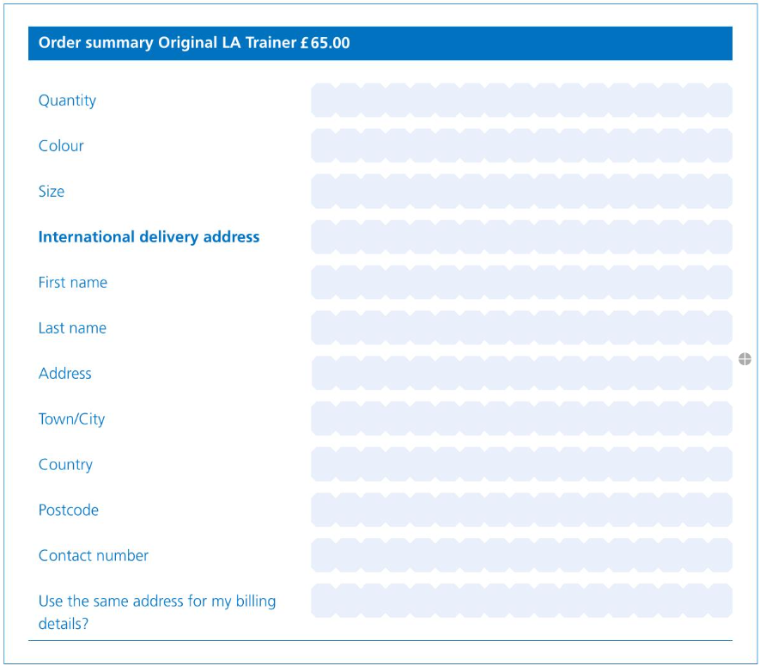
STEP 3:
- Centrepoint uses the money to let a young person sleep in a B&B once in a while.

- As a sponsor you can choose which person you want to help.
- The sponsor gets information about the room he sponsors and about the person staying in it.

- You get a discount if you sponsor more rooms.
STEP 4:
- How do they make the reader enthusiastic for their “product”?
- Which verb tense do they use the most in the advert?
- How do they make the advert appealing?
- What do they use the small print (kleine lettertjes) for?
STEP 16:
STEP 19:
STEP 24: GRAMMAR NOTES

STEP 30/31
STEP 35

