Songwriter Nobel Winner

You may have heard that Bob Dylan received the 2016 Nobel prize for literature because of his poetic lyrics in his songs. People are now debating: do song lyrics have the same artistic value as poetry or novels?

The musician
The 75-year old musician was born as Robert Allen Zimmerman in 1941 in Minnesota. For more than 50 years though, the world has known him as Bob Dylan. Following his first album in 1962, he has released 38 albums, which have sold more than 125 million copies. He’s still giving concerts to his fans on his Never Ending Tour, which began in 1988.

Why a literature prize
How can a musician be given a literature prize? Some say his song texts are just like poetry. Take for example the following verse from his protest songThe Times They Are a-Changin’ (1964), meaning don’t be so quick to criticize the dreams you had when you were young.
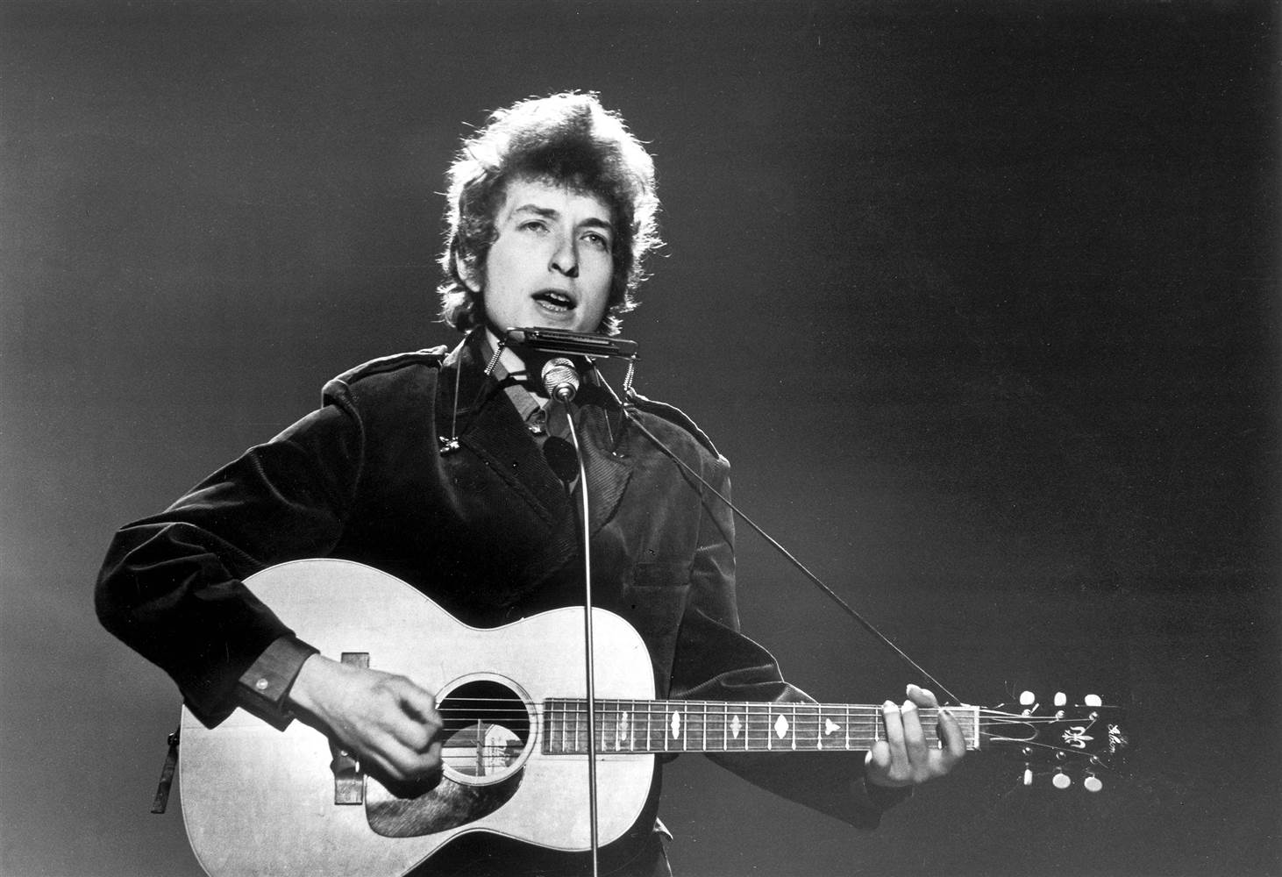
Come mothers and fathers
Throughout the land
And don’t criticize
What you can’t understand
Your sons and your daughters
Are beyond your command
Your old road is rapidly agin[g]
Please get out of the new one
If you can’t lend your hand
For the times they are a-changin[g]

Criticism
Writers from all over the world do agree that Bob Dylan is the finest singer-songwriter. But can a songwriter be so good that he wins the Nobel literature prize? People then are not too sure. Older authors think it is a ‘great choice’. But younger writers think it’s the same as giving the prize to ‘Obama for not being Bush’. A writer tweeted: ‘I’m happy for Bob Dylan, #ButDoesThisMeanICanWinAGrammy?’

The prize winner himself
Bob Dylan has won many prizes in his career. Yet, he often collects his awards in private. Even now, instead of giving a press conference, he was singing on stage. And instead of stopping to say thank you publicly on stage, he remained silent. He is an unusual Nobel winner.
Source: www.nytimes.com; www.theguardian.com

Words to help you
a novel = a literary book
a grammy = a music prize

