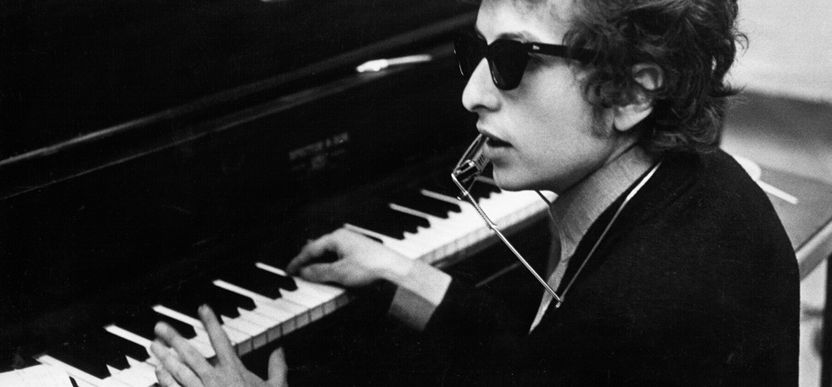
Finest Songwriter, but Nobel Prize Winner?

You may have heard that Bob Dylan is the recipient of the 2016 Nobel prize for literature for ‘having created new poetic expressions within the great American song tradition’. The debate is now raging: do song lyrics have the same artistic value as poetry or novels?

The musician
The 75-year old musician, whose original name was Robert Allen Zimmerman, was born in 1941 in Minnesota. For more than five decades the world has known him as Bob Dylan. His first album was released in 1962. Since then, his 38 albums have sold more than 125 million copies. He’s still performing live to audiences on his Never Ending Tour, which began in 1988. Needless to say he’s an icon having profoundly influenced modern day music.

Why a literature prize
How can a musician be awarded a literature prize? Some say he reflects the oral, or spoken, tradition of the ancient Greek poets Homer and Sappho. They wrote poetic texts that were meant to be listened to. Likewise for Bob Dylan. Take for example the following verse from his protest song The Times They Are a-Changin’ (1964), meaning don’t be so quick to criticize the dreams of your youth.

Come mothers and fathers
Throughout the land
And don’t criticize
What you can’t understand
Your sons and your daughters
Are beyond your command
Your old road is rapidly agin’
Please get out of the new one
If you can’t lend your hand
For the times they are a-changin’

Controversial
Writers from all over the world are all in agreement. Bob Dylan is the finest singer-songwriter, yet does that make him worthy of the Nobel literature prize? Here is where the camps divide. It seems that older writers, such as Stephen King and Salman Rushdie, believe it to be a ‘great choice’. Whereas younger writers call it the same as giving the prize to ‘Obama for not being Bush’. People fear that by doing this, a Nobel prize is less elite. A novelist remarked in a tweet: ‘I’m happy for Bob Dylan, #ButDoesThisMeanICanWinAGrammy?’

The prize winner himself
What may be even more controversial, is the prize winner himself. Bob Dylan has been awarded many prizes in his career. Yet, his award ceremonies have, more than often, been behind closed doors. Even now, he gave no news conference on the day as he was performing. Instead of taking the chance on stage to give thanks for the honour, he remained silent. He most certainly is an unusual Nobel winner.
Source: www.nytimes.com; www.theguardian.com

