 READ THE TEXT & FOCUS ON UNKNOWN WORDS

- You are about to read the text California Fires. Look at the picture, the title and the headings of the text. What is the text about?

- Read the text. Use the Step-by-Step Reading Guide. Underline or mark the words you don’t understand while reading.

- Read the explanation.

When you see a word that you don’t understand, you can use the Word help.
If you don’t get any clues about the meaning of the word from the text itself, you can look it up in a dictionary. That is the last step of the Word help.

How does a dictionary work?
To look up a word in a dictionary, you use the alphabet.
- What is the first letter of the word?
Is it, for example, a ‘w’? Then you start looking at the end of the dictionary. Not at the beginning.
- On top of every page in a dictionary you see a few words.
The words start with certain letters. They help you to see if you are looking in the right place.
For example: you are looking for a word that starts with a ‘g’. You open the dictionary and see the word ‘good’. Then you know that you are looking in the right place.
- Look at the second letter of the word, then the third, the fourth and so on. For example: you are looking for the word ‘luck’. You open the dictionary at the page with the words ‘low’ - ‘lumber’. Then you know that you have to look at this page. The letters of the word ‘luck’ come after the word ‘low’ and before the word ‘lumber’.

Sometimes a word has different meanings. Always check which meaning fits best in the text!

- Read line 2: (…) you receive a Twitter message telling you to leave your home immediately.
What does immediately mean? Look it up in your dictionary and write down:

immediately means:_______________________________________

- Read line 3: (…), watching it being destroyed by the flames.
What does destroyed mean? Look it up in your dictionary and write down:

to destroy means: ____________________________________________

- Read line 6: Wildfires
What does wildfires mean? Look it up in your dictionary and write down.

the wildfire means: _____________________________________________

- Read line 11: (…) Paradise has been literally wiped off the map.
What does wiped off mean? Look it up in your dictionary and write down:

to wipe off means: _____________________________________________

- Read lines 22-23: Climate change results in less rain falling.
What does results in mean? Look it up in your dictionary and write down:

to result in means:______________________________________________

- Read line 24: (…) autumn.
What does autumn mean? Look it up in your dictionary and write down:

the autumn means: ____________________________________________

- Read line 26: (…)have not been allowed (…).
What does allowed mean? Look it up in your dictionary and write down:

to allow means: _____________________________________________

- Probably you have underlined or marked more difficult words. What do these difficult words mean? Look them up in your dictionary too.

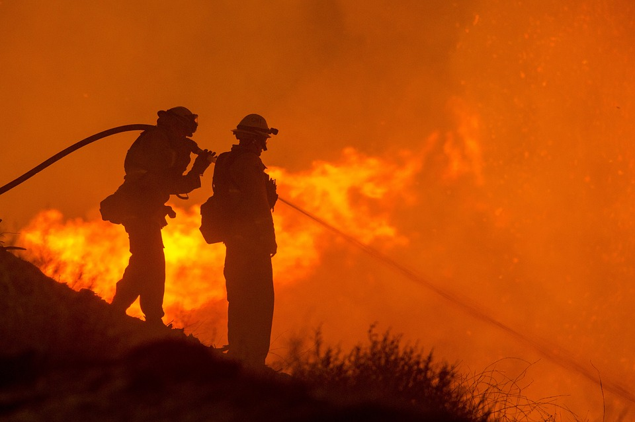

 PROBLEM-CAUSE-SOLUTION 

The text California Fires gives you information about a problem, what the causes are of this problem, and what a solution to this problem could be. In the chart below, you can write all this information down. This gives you a good overview of the text.

Complete the chart and use the information from the text.

CAUSES | PROBLEM | SOLUTION
1.  2.  3.  4. |  | According the text:  Can you think of other solutions that can possibly solve the problem?

 ANSWER THE QUESTIONS

- Read lines 14-18. Why is the fire season from June to September less deadly than the fire season from October to April?

___________________________________________________________________

- What is true?
- The most large fires in California have been since 2000.
- There have been two large fires in California caused by people.
- Wildfires are very unusual in California.

- Read again the text below Key to wildfires. Why were the plants and trees so dry in Paradise?

___________________________________________________________________

___________________________________________________________________

- In line 25 you read that people can cause fires. How can this happen, do you think? Give two examples.

___________________________________________________________________

___________________________________________________________________

 WRITE THE TWITTER MESSAGE
In the introduction you read that the people of Paradise received a Twitter message telling them to leave their home.
Write down the message yourself.
Tell the people, for example, what is happening, what they have to take with them, when and how they must go away.
Don’t use more than 280 signs.

___________________________________________________________________

___________________________________________________________________

___________________________________________________________________

___________________________________________________________________

___________________________________________________________________



