California Fires

Just imagine: you receive a Twitter message telling you to leave your home immediately. You get into your car with your family. You drive out of your town, watching it being destroyed by the flames. All the while hoping you will stay alive. This happened last Thursday to the 27,000 people of Paradise, a town in North California.

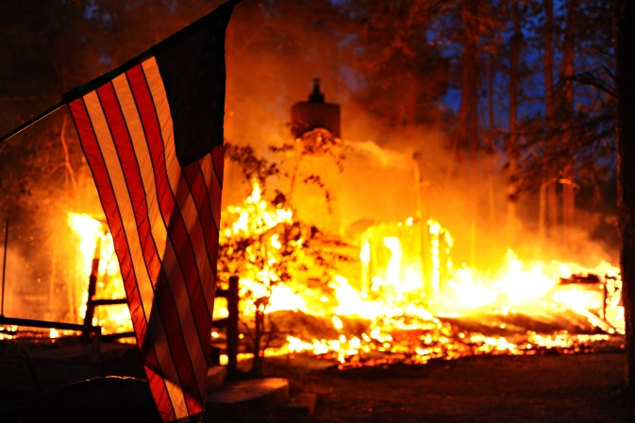
Wildfires
This wildfire in Paradise, called Camp Fire, has killed more than 40 people and burnt down more than 7,1 00 buildings, mostly homes. There are still more than 200 people missing. In fact, Paradise has been literally wiped off the map. At the same time, a wildfire, called Woolsey Fire, is burning many houses in Malibu, South California.

Fires in California
Wildfires are not unusual in California. There are two fire seasons. The first one, from June to September, is less deadly. It burns higher up in the mountains where people do not live. The second, from October to April, is caused by the Santa Ana winds, and burns three times faster and closer to areas where people live.

Key to wildfires
In California, there have been 10 large fires since 1932. Nine of them since 2000. Just this year, there have been two. There are four key points that cause these wildfires: climate change, people, fire suppression, and the Santa Ana winds. Climate change results in less rain falling. In Paradise, for example, less than half the normal amount of rain fell this autumn. The Santa Ana winds blow in hot, dry wind from the northeast, making the plants and trees that are dry, even drier. People cause fires, by accident or on purpose. For years, natural fires have not been allowed to burn out, but have been suppressed. By not letting nature control itself, people have made the problem worse.

Stop fires from happening
‘There are millions of dollars going into fighting fires but there are not millions going into stopping fires from happening,’ says a wildfire expert. We need to think about how we design our towns and build our homes, he says.

Sources: www.nytimes.com; www.sfchronicle.com;

Words to help you
deadly = will probably cause death
fire suppression = to prevent or stop a fire from burning out

