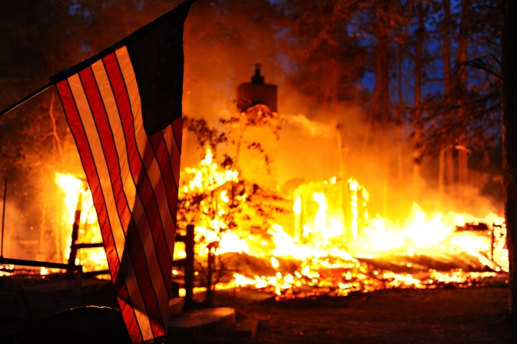
California Burning

A popular song sang about ‘California Dreaming’. However, at present, it is more realistic to sing ‘California Burning’. Picture this: you receive a Twitter message telling you to evacuate. You get into your car with your family. You drive out of your town, watching it being destroyed by the flames. All the while hoping you will survive. This happened last Thursday to the 27,000 inhabitants of a town called Paradise, in North California.

Wildfires
This wildfire in Paradise, named Camp Fire, has already cost more than 40 lives, more than 200 people are unaccounted for, or missing, and 7,100 buildings, mostly homes, have been burnt to ashes. In fact, Paradise has been literally wiped off the map. Yet, not only Paradise has been affected by such a devastating wildfire. In Malibu, South California, the Woolsey Fire has also destroyed properties.

Fires in California
Wildfires are not uncommon in California, which has two fire seasons. The first one, from June to September, is less deadly, as it tends to be more inland and higher up in the forests where people do not live. The second, from October to April, is driven by the Santa Ana winds, and burns three times faster and closer to urban areas, therefore dangerous for people. The Golden State has become a year-round danger zone for fire catastrophe.

Key to wildfires
What makes wildfires in California so catastrophic? There are four key ingredients: climate change, people, fire suppression, and the Santa Ana winds. Climate change may seem obvious, but here are some facts. California has just had a five-year drought. In Paradise, for example, less than half the normal amount of rain fell this autumn. The Santa Ana winds that blow in hot, dry wind from the northeast, make the plants and trees that are dry because of lack of rain, bone-dry, ready to burn at the slightest spark.

Other ingredients
In California, there have been 10 large fires since 1932. Nine of them have occurred since 2000, and just this year there have been two. People and fire suppression also cause fires. People cause fires, by accident or on purpose. Also, people are building homes nearer to forests. For years, natural fires have not been allowed to burn out, but have been suppressed. By not letting nature control itself, man has created a larger problem. There are more dry plants on the ground, making present-day wildfires worse.

Preventing fires
‘There are millions of dollars going into fighting fires but there are not millions going into preventing fires’ says a wildfire expert. We need to think about how we design our towns and build our homes he says. Then it may turn into ‘California Dreaming’ again.
Sources:www.nytimes.com; www.sfchronicle.com;

